**How to Obtain**

**Business Intelligence Service Line (BI**

**FY14 Annual Report**

**Access to the**

**Corporate Data Warehouse (CDW)**

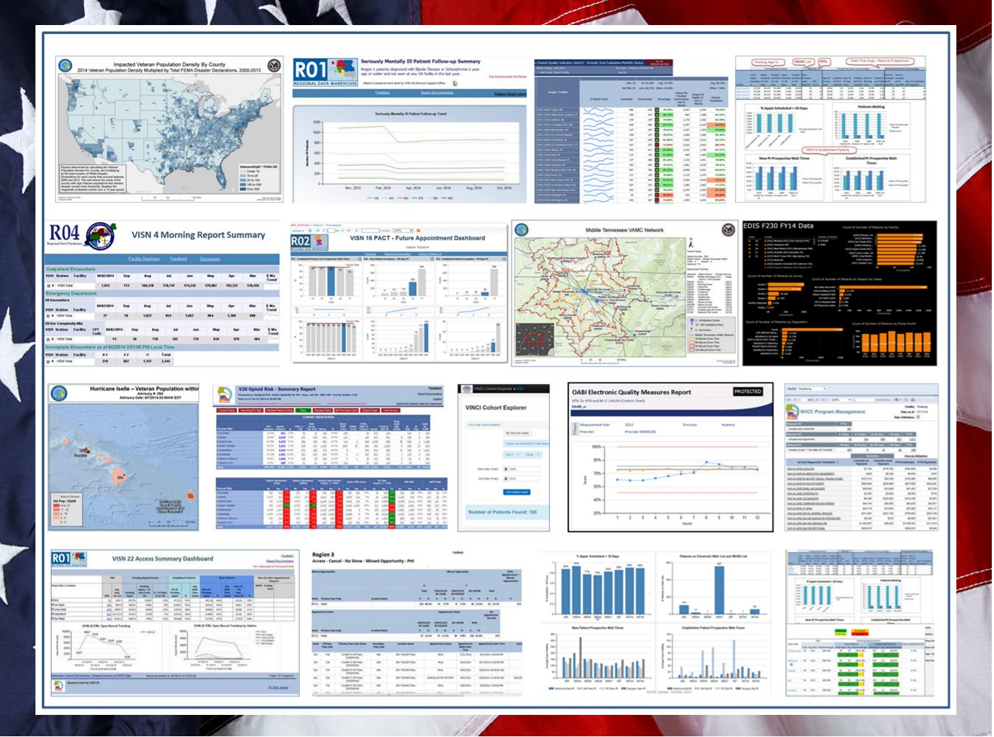

**Business Intelligence Service Line**

**U.S. Department of Veteran Affairs**

**January 2015**

**Table of Contents**

I. Getting Started 2

**Step 1:** **Determine Level of CDW Data Needed** 2

II. National Data Access 2

**Step 2:** **Complete NDS Access Form** 2

Step 2a: Determine Dataset(s) 2

**Step 3:** **Wait for NDS Decision** 4

III. Accessing CDW Data 5

**Step 4:** **Complete a Project Request Form** 5

IV. Local Data Access 5

Appendix A: CDW Data Access Levels 6

Appendix B: CDW Data Access Process 7

# Getting Started

## **Step 1:** **Determine Level of CDW Data**

If you do not currently have access to CDW data, the first step is to determine whether you need access to your station or VISN level data, or if you need access to national level data. If you already have access to CDW data, proceed to Section III. For additional information on determining what level of data you require, see Appendix A.

**Local and/or multiple station/VISN data** - Proceed to Section IV

**National data** – Proceed to Step 2

# National Data Access

## **Step 2:** **Complete NDS Access Form**

To request access to national data, authorization by the National Data Services (NDS) group is required. NDS requires a form to be submitted with the category of data you want access to and how you will be using the data. The form is titled “**VHA NDS Access Form for Health Operations**" and is located here, [NDS CDW Access Form](https://epas.r02.med.va.gov/submit.cfm?action=select&doc_type=690)

Complete each section and boxes as the form requests. Review the [NDS ePAS User Request Guide](http://vaww.vhadataportal.med.va.gov/Portals/0/Forms/NDS_ePAS_UserRequestGuide.pdf) for additional instructions on how to complete the form.

Frequently Asked questions about this process are available [here](https://vhacdwmul24.vha.med.va.gov/faq/Access.aspx).

### **Step 2a: Determine Dataset(s)**

Once the checkbox for “Corporate Data Warehouse (CDW)” is selected in the form, a tab titled “Corporate Data Warehouse” will appear at the top of the form. Use ‘Table 1 – CDW Dataset Categories’ to determine the overall data category (CDW SQL Datasets; CDW SAS Datasets; Non CDW Data) and subsequent dataset(s) you may need to query. More than one dataset can be selected, so select the dataset(s) that best meet your needs. (**Note:** ‘Basic Read Access’ comes with all additional SQL and SAS Datasets and will automatically be selected when an additional dataset is selected.)

Once you have selected the appropriate dataset(s), return to the main tab (“Request”) and finish completing the form.

**TIP:** Once you have submitted the form, save a link to the Electronic Permission Access System (ePAS) site. This will allow you to quickly view the status of your request.

**Table 1 - CDW Dataset Categories**

| Security Group | Description | Active Directory Group |
| --- | --- | --- |
| CDW SQL Datasets | | |
| Basic Read Access | **Authorization Includes:** Provides access to every extracted table in the CDW, which includes but is not limited to, basic demographic data, station specific identifier of a patient, and VA wide identifier (Patient ICN) to uniquely identify a patient among all VA stations.  **Authorization Does Not Include:** Patient Real SSN, scrambled SSN, Patient Name and other identifiers.  For access to this information you will need access to ‘Privileged Read Patient Access’ Dataset.  For access to Staff or Employee Real SSN, names and other identifiers, you will need access to ‘Staff Real SSN Access’ Dataset. | CDW_Full |
| Privileged Read Patient Access | **Authorization Includes:** All patient demographic data, real SSN, scrambled SSN, Patient Name and other identifiers, station specific identifier of a patient, and VA wide identifier (Patient ICN) to uniquely identify a patient among all VA stations.  Basic Read Access is also required | CDW_SPatient |
| Staff Real SSN Access | **Authorization Includes:** Employee real SSNs.  Basic Read Access is also required | CDW_SStaff |
| MCA (DSS) Access | **Authorization Includes:** Real SSNs and scrambled SSN DSS NDE data in SQL format  Basic Read Access is also required | CDW_DSS |
| Vital Status Files | **Authorization Includes:** Vital Status files and real SSNs.  Basic Read Access is also required | CDW_VitalStatus |
| CDW SAS Datasets | | |
| Medical SAS Files | **Authorization Includes:** File-based SAS Datasets. These data sets include patient SSN.  Basic Read Access is also required | CDW_SASData |
| Non CDW Data | | |
| Non CDW Data (Special Projects) | **Authorization Includes:** Use of CDW resources without using CDW data | CDW_nonCDWPHI  CDW_nonCDWNonPHI |

## **Step 3:** **Wait for NDS Decision**

Once the form has been submitted, it is routed to the supervisor and then the ISO identified in the form for approvals. The duration of receiving these signatures is dependent on how quickly the supervisor and ISO respond and approve. After these two signatures are received, NDS approval takes, on average, a week.

**TIP:** To ensure the signature approval process is timely, contact your supervisor and ISO directly and inform them of your need for their approval.

Additional information about the NDS Healthcare Operations Process can be found on here, [NDS Authorization Process](http://vaww.vhadataportal.med.va.gov/DataAccess/HealthcareOperationsRequestProcess.aspx). You can also monitor the progress of the form by logging into the [ePAS site](https://epas.r02.med.va.gov/).

For general VHA National Data System (NDS) questions, contact the NDS Helpdesk at

[VHADataPortal@va.gov](mailto:VHADataPortal@va.gov). For questions related to the Healthcare Operations Request Process, send questions to [NDS.OperationalAccessRequests@va.gov](mailto:NDS.OperationalAccessRequests@va.gov)

**CDW Authorization Granted**

Once authorization has been granted by NDS, your information is entered into the CDW Tracker Database. The Tracker Database will automatically send a notification that you are now authorized to begin accessing CDW data. Follow the instructions in the e-mail.

**Sample ‘Authorization Granted’ E-mail**

“This operational access request has been authorized by National Data Systems for CDW per your request.

For further instructions for CDW access, follow the link to the CDW Support site, then click “CDW Guide: Introduction and Policies”, under Guides in the left-hand navigation pane.

Please allow several hours for the changes to update throughout the network before requesting CDW Support (although it may not take that long to update).  After reviewing the CDW support web link, if more immediate action in necessary, please contact the Austin Nat’l Service Desk via telephone at 855-NSD-HELP (855-673-4357), option 5, or via this web link <http://vaww.aac.va.gov/servicedesk>.”

**CDW Authorization Denied:** NDS will notify you if authorization is denied. Continue to work with the NDS helpdesk to resolve.

# Accessing CDW Data

## **Step 4:** **Complete a CDW Resource Request Using BaseCamp**

To request CDW resources such as a new workgroup or to request additional CDW services, determine what type of service is needed by reading the [Workgroups and Development Guide](https://vaww.cdw.va.gov/support/Shared%20Documents/Best%20Practices/CDW%20Guide%20Workgroups%20and%20Development.docx) and then submit a request using the new [BaseCamp](https://vaww.cdw.va.gov/support/SitePages/CDWSupportHome.aspx) application on the CDW Support SharePoint portal.

For instructions on how to access CDW servers and data please review the [CDW Guide: Introduction and Policies](https://vaww.cdw.va.gov/support/Shared%20Documents/Best%20Practices/CDW%20Guide%20Introduction%20and%20Policies.docx).

For additional information on querying CDW data and available CDW services, please refer to the [CDW Guide: Projects and Development](https://vaww.cdw.va.gov/support/Shared%20Documents/Best%20Practices/CDW%20Guide%20Workgroups%20and%20Development.docx) and [CDW Guide: Query Best Practices](https://vaww.cdw.va.gov/support/Shared%20Documents/Best%20Practices/CDW%20Guide%20Query%20Best%20Practices.docx).

If you have additional data access questions or questions regarding the project request form, contact the CDW Help Desk at [CDWSupport@VA.Gov](mailto:CDWSupport@VA.Gov) .

# Local Data Access

To request access to your local station or VISN data, please use the following link and follow the instructions: [https://vaww.dwh.cdw.portal.va.gov/sites/security/default.aspx](https://vaww.cdw.va.gov/sites/security/default.aspx)

# Appendix A: CDW Data Access Levels



# Appendix B: CDW Data Access Process

